Next Year Purchasing
Using the Next Year Purchasing option will allow users to enter Requisitions that need to be charged against next year’s budget into the Purchasing application. This may save time and frustration during the back to school rush.

Setting Up Next Year Purchasing:
Note: Next Year Requisitions are only validated against the account codes established in Budget, and not against the amounts budgeted. Because of this, it is possible for Requisitions to be approved that would overspend the budget.
_____1. Verify Account Codes in Budget: Budget > Maintenance > Budget Data – verify that the account codes in Budget have been rolled up to the new fiscal year.

_____2. Review Manage Roles which will affect all users assign to that role: Security Administration > Manage Roles. In the Security Administration application, an existing role can be updated or a new role can be created to be added to a user that is specific to NYR in Purchasing. It is possible to simply add NYR to an existing role by Editing the Role as shown in Option 1. We recommend creating a separate role as shown in Option 2. This will allow you to un-assign CYR in Purchasing to force users to use NYR only if desired.

Option 1: The following screen shot is an example of an existing role to be updated for all users who will be responsible for entering NYR. This will affect all users that are assigned to this role. If your district currently uses NYR and no changes need to be made, skip to step 4.

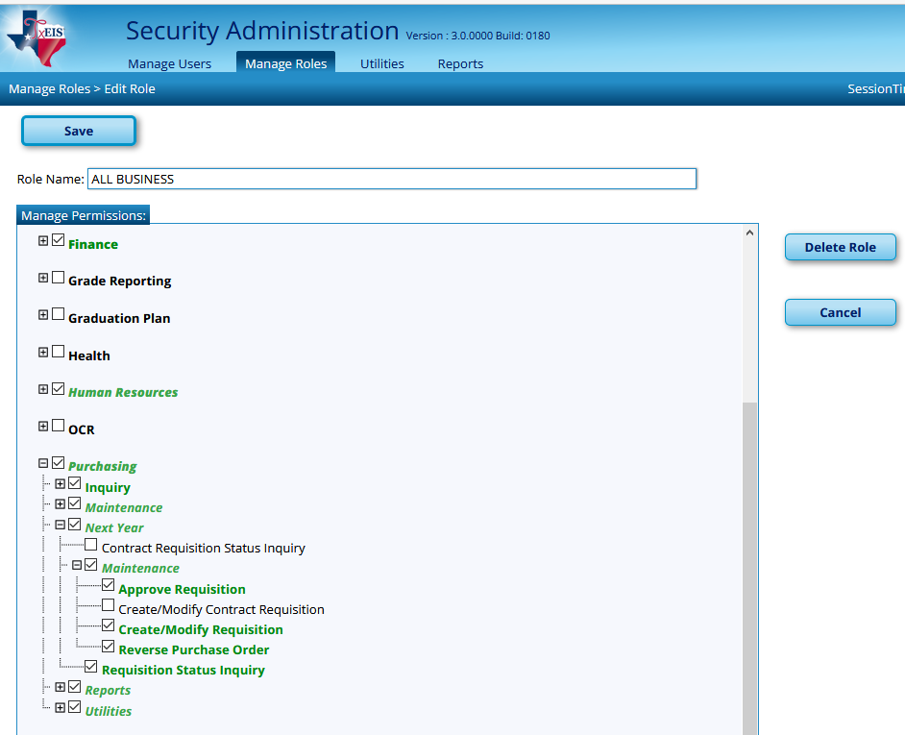

Option 2: Create a Next Year Purchasing role to be assigned only to certain users:
Security Administration > Manage Roles. Select Create New Role.

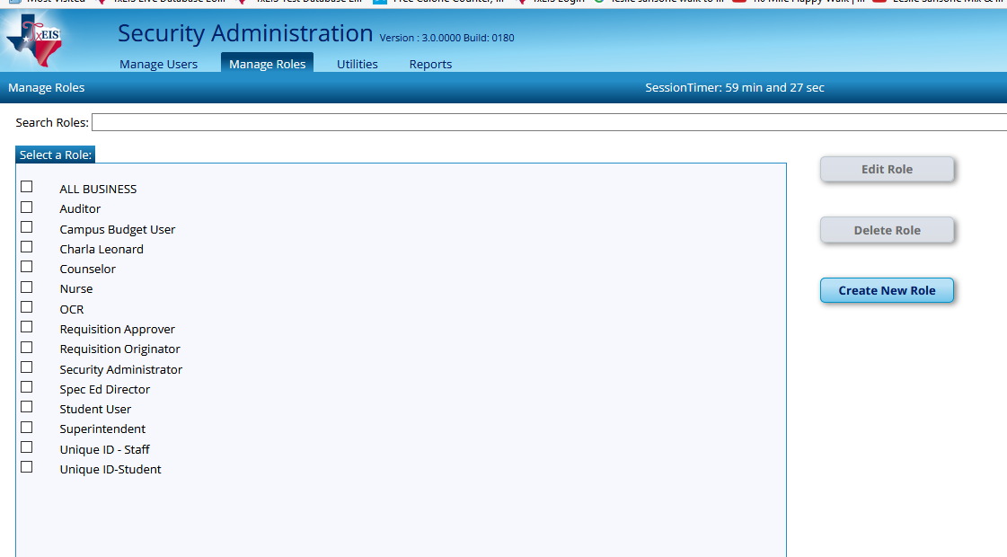

You will need to enter a Role Name such as NYR Purchasing Requester or NY Purchasing Approver.
Select the + sign next to Purchasing to see all possible permissions.
- Click on the + sign next to Next Year.
- Click on the + sign next to Maintenance and select desired permissions
- Approve Requisition
- Create/Modify Requisition
- Reverse Purchase Orders and
- Requisition Status Inquiry
Be sure to SAVE.
The following screen shot is an example of a role for a user who will be responsible for Approving NYR in Purchasing.

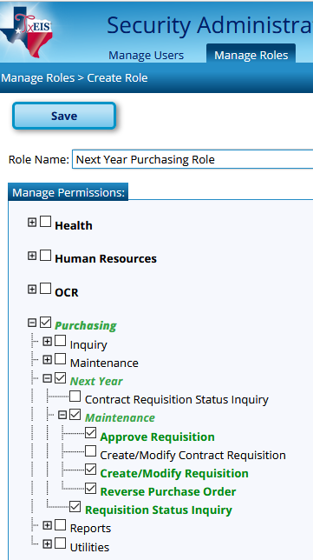

Once this has been created you will assign this role to a user that is specific to Next Year Purchasing. Select Manage Users > Enter NYR User name and click find.

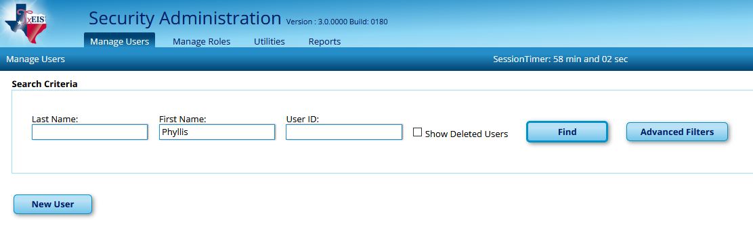

Check the box beside the Users Name. You will then select Edit User.

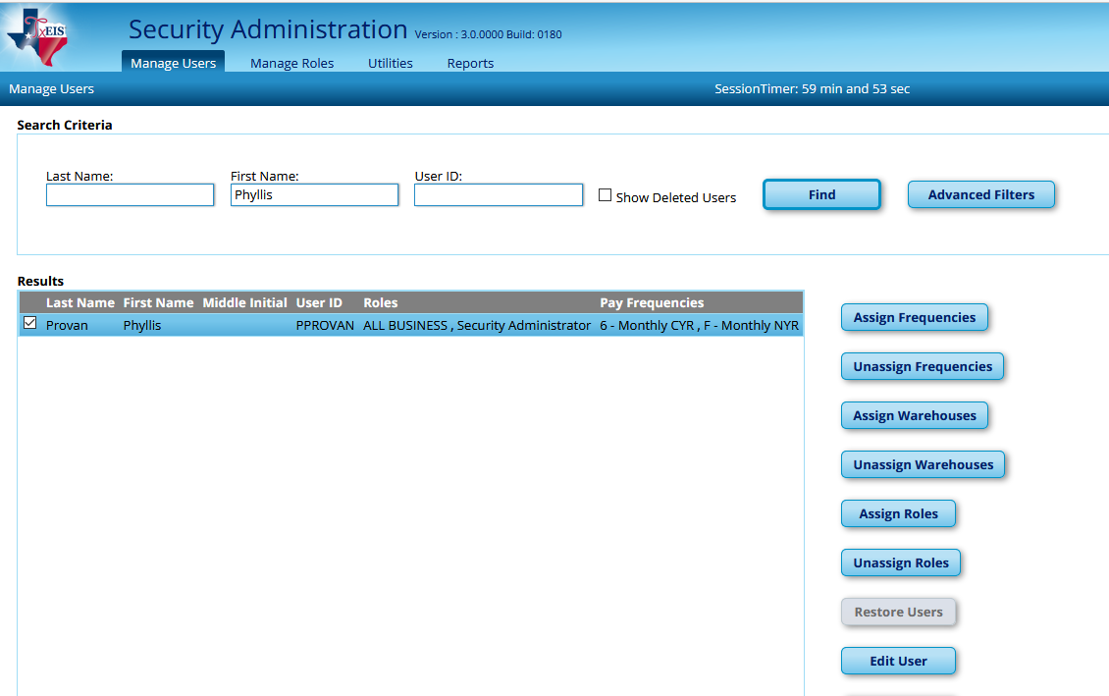

Click Add under Roles - Check NYR Purchasing or the name that you assigned to this role - Click OK.
You will do this to all users that you would like to have access to NYR Purchasing.

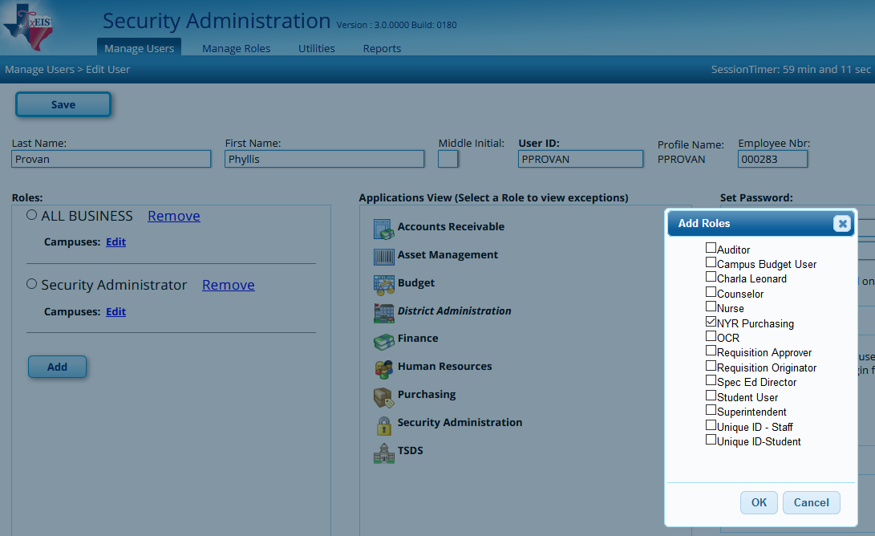

If your district currently uses NYR Purchasing and no changes need to be made, skip to step 4.

_____3. Determine the numbering system: Finance>Tables>District Finance Options. In the Purchasing Options box, you can designate the numbering system you would like to use for Next Year Requisitions and NYR PO’s.

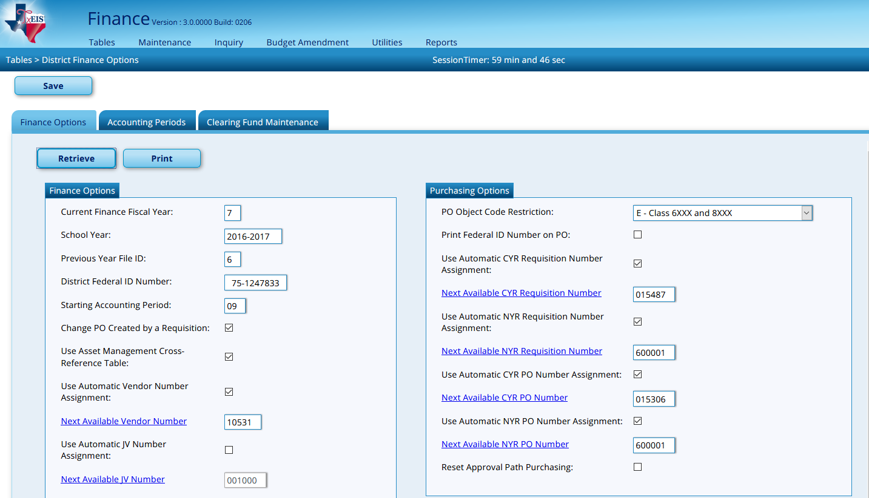

____4. Review the Purchasing Options: District Administration > Options > Purchasing Options > Next Year tab. Review and make adjustments to the Options table as needed. This tab allows the user to select the options used in setting up Purchasing tables and files for the next year. These fields will need to be updated prior to entering a NYR requisition.
Note: Typically we do not use a Cutoff Date on our Current Year Options Table. We recommend a cutoff date for Next Year Requisitions so that users do not inadvertently enter their requisitions into Next Year once the new school year has begun.
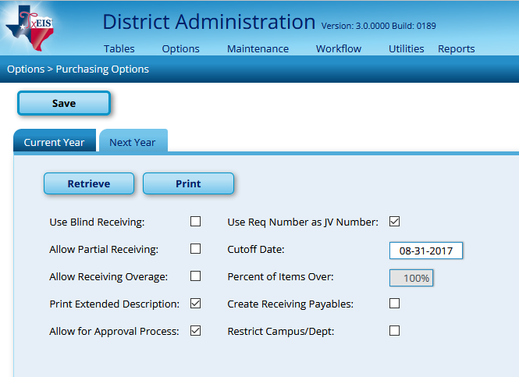

_____5. Add any new users and delete any users who will not be returning to your district next year. To be available for addition in User Profiles, the new user must have been built in Security.
To add: From District Administration > Maintenance > User Profiles, select the Add User button. A popup box will display. You can enter the name, employee number or leave blank and click Retrieve. There will be a list of users who have not been set up in the User Profile. Select the new user’s Employee Nbr. Double check to ensure the new user is displayed in the User ID field then set desired access on each tab. Save each tab separately.
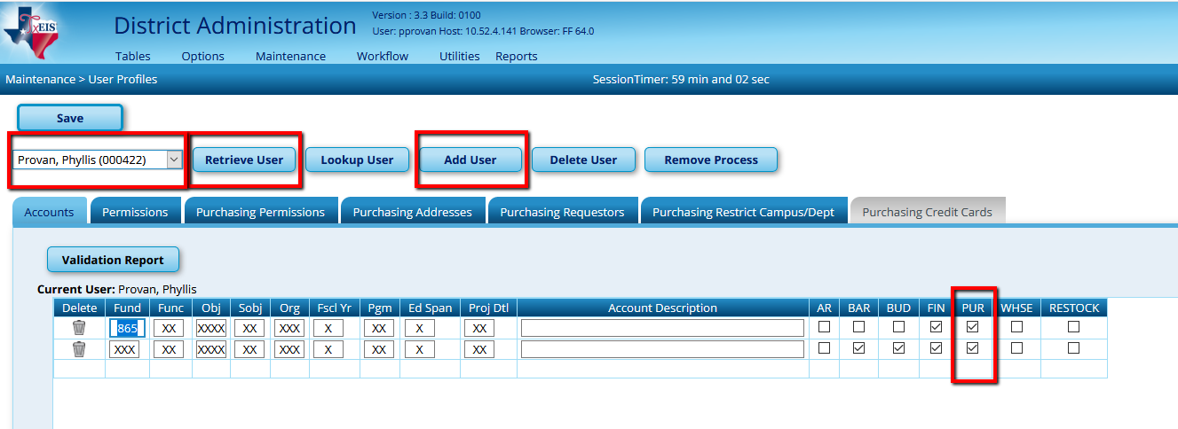

To delete: Select the desired user from the dropdown and Retrieve. Ensure the desired user is displayed in the Current User Field. Click Dlete User. A message will display asking Are you sure that you want to delete the user. Select OK.
_____6. Review User Profiles: From District Administration > Maintenance > User Profiles, review and update each user in the dropdown list. Review each tab, making changes as needed and Save. You must click Save for each tab.
Important note: Each time you select a user from the dropdown, remember to click Retrieve and verify the Current User displays the user you wish to review/update. Even though the user may display in the dropdown, if he/she is not the user listed in the Current User field, you will not be updating the desired user.

_____7. Review User Account Codes: From the Maintenance > User Profiles > Accounts tab.

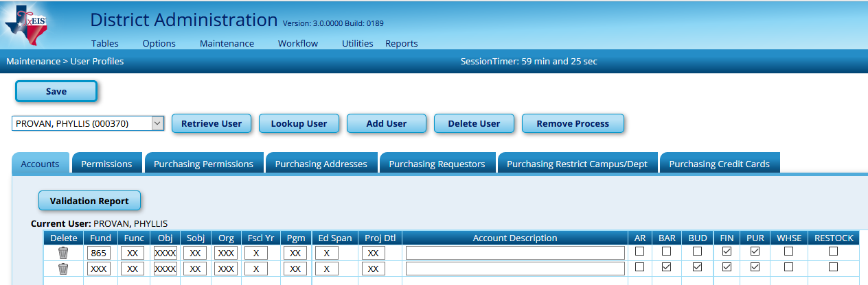

Notes: Things to remember about NYR Requisition
- Account Codes used in Next Year Requisitions validate against Budget instead of Finance.
- Next Year Requisitions cannot be created for Student Activity Funds. There are no 2XXX accounts in Budget. Since NYR validates against Budget, these account codes are not available.
- A prior fiscal year cannot be used in Next Year Requisitions unless it exists in Budget. For example, in the 2016-2017 school year the federal funds for fiscal year 7 could still be spent through September 30. There is a validation to prevent you from entering a requisition using a prior fiscal year (to keep you from doing it by mistake.)

Users are now ready to begin using Next Year Purchasing.
- Enter new Requisitions from Next Year > Maintenance > Create/Modify Requisition. You will follow the same steps you use when entering a Current Year Requisition but in the Next Year Requisition screen.

- Approve Next Year Requisitions (if you are going to allow approval at this time) from Next Year > Maintenance > Approve Requisition, you will follow the same steps you use when Approving a Current Year Requisition but in the Next Year Requisition screen.

- Reverse Next Year POs from Next Year > Maintenance > Reverse Purchase Order.
You will follow the same steps you use when Reversing a Current Year Requisition but in the Next Year Requisition screen.

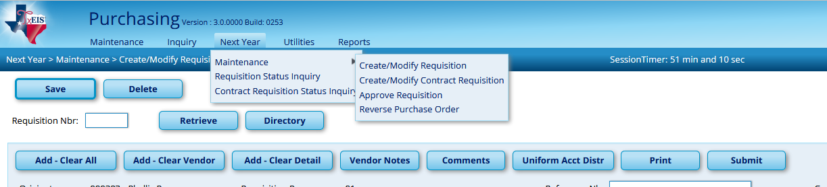

- Inquire on the status of a Next Year Requisition from Next Year > Requisition Status Inquire.

